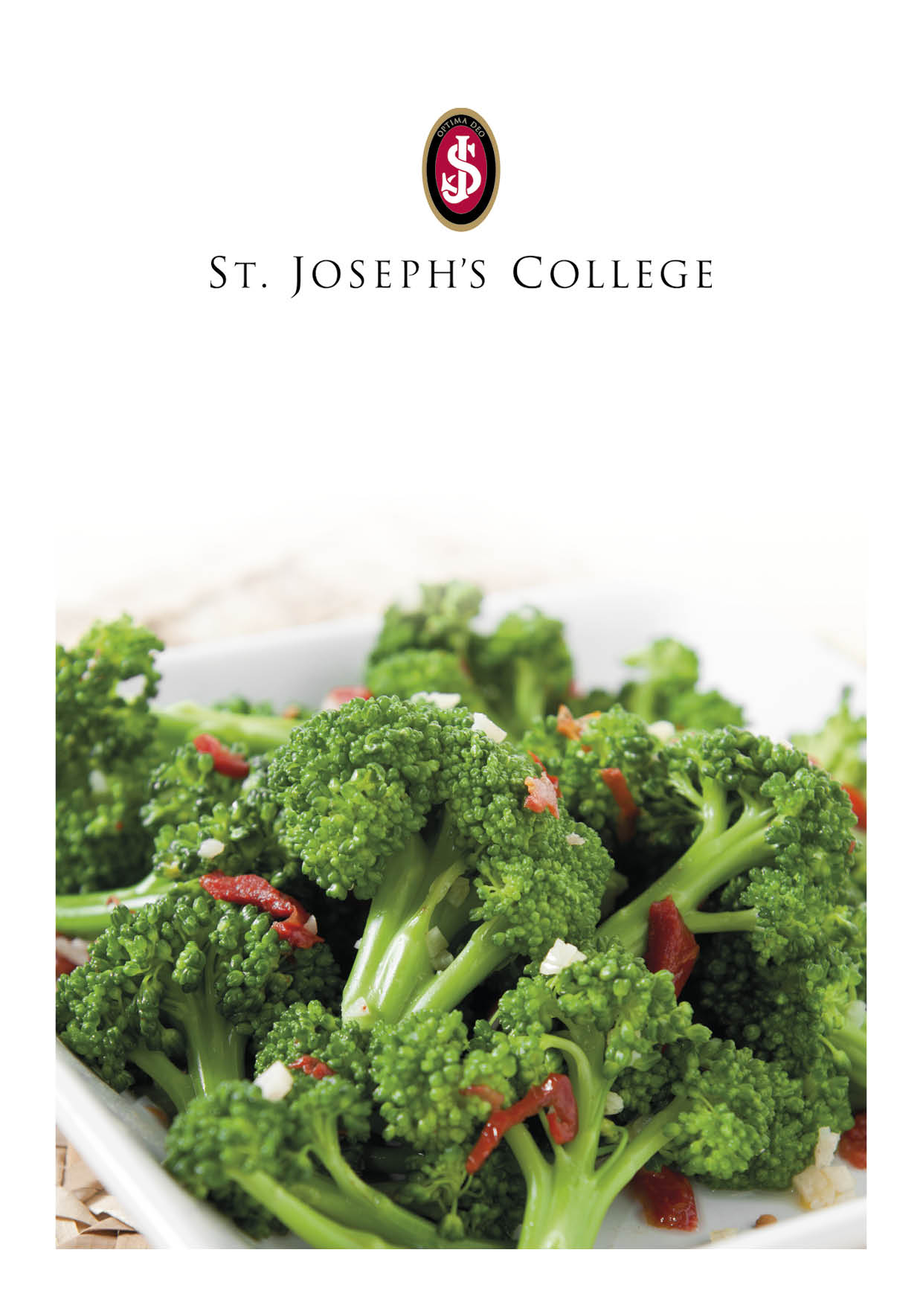
Week Commencing 03 June 24
Monday | Tuesday | Wednesday | Thursday | Friday
Soup of the Day  Carrot & Coriander  served with Home Made Bread  Dish of the Day  Sausage Casserole with a Onion Gravy  Vegetarian Option  Vegetable Sausage with a Onion Gravy  Sides  Mash Potato  Red Cabbage  Garden Peas  Pudding  Jam filled Doughnut  Available Daily  Jacket Potatoes  Baked Beans  Pasta  Salad Bar  Fresh Fruit | Soup of the Day  Mexican Mixed Bean  served with Home Made Bread  Dish of the Day  (Pasta Bar)  Chicken and Spinach in a Tomato Sauce  Vegetarian Option  Chunky Roast Vegetable in a Cheese Sauce  Sides  Green Beans  Roast Courgettes  Pasta in a Red Pesto Dressing  Pudding  Pancake served with a Orange Custard  Available Daily  Jacket Potatoes  Baked Beans  Pasta  Salad Bar  Fresh Fruit | Soup of the Day  Minestrone  served with Home Made Bread  Dish of the Day  Butchers Beef Burger  Vegetarian Option  Breaded Vegetable Bean Burger  Sides  Potato Wedges  Sliced Cheese  Beef Tomato  Coleslaw  Sweetcorn  Sautéed Onions  Pudding  Vanilla Panna Cotta topped with a Raspberry Sauce  Available Daily  Jacket Potatoes  Baked Beans  Pasta  Salad Bar  Fresh Fruit | Soup of the Day  Broccoli & Stilton  served with Home Made Bread  Dish of the Day  (Taco & Fajita Bar)  Chipotle Chicken  Vegetarian Option  Roasted Vegetable & Jack Fruit  Sides  Guacamole  Cream Cheese and Chive  Jalapenos  Vegetable Rice  Pudding  Pear and Apple Crumble with Custard  Available Daily  Jacket Potatoes  Baked Beans  Pasta  Salad Bar  Fresh Fruit | Soup of the Day  Smoked Haddock Chowder  served with Home Made Bread  Dish of the Day  Breaded Cod  Vegetarian Option  Three Cheese Macaroni  Sides  Twice cooked Chips  Mushy Peas  Baked Beans  Pudding  Vanilla Ice Cream  Available Daily  Jacket Potatoes  Baked Beans  Pasta  Salad Bar  Fresh Fruit

