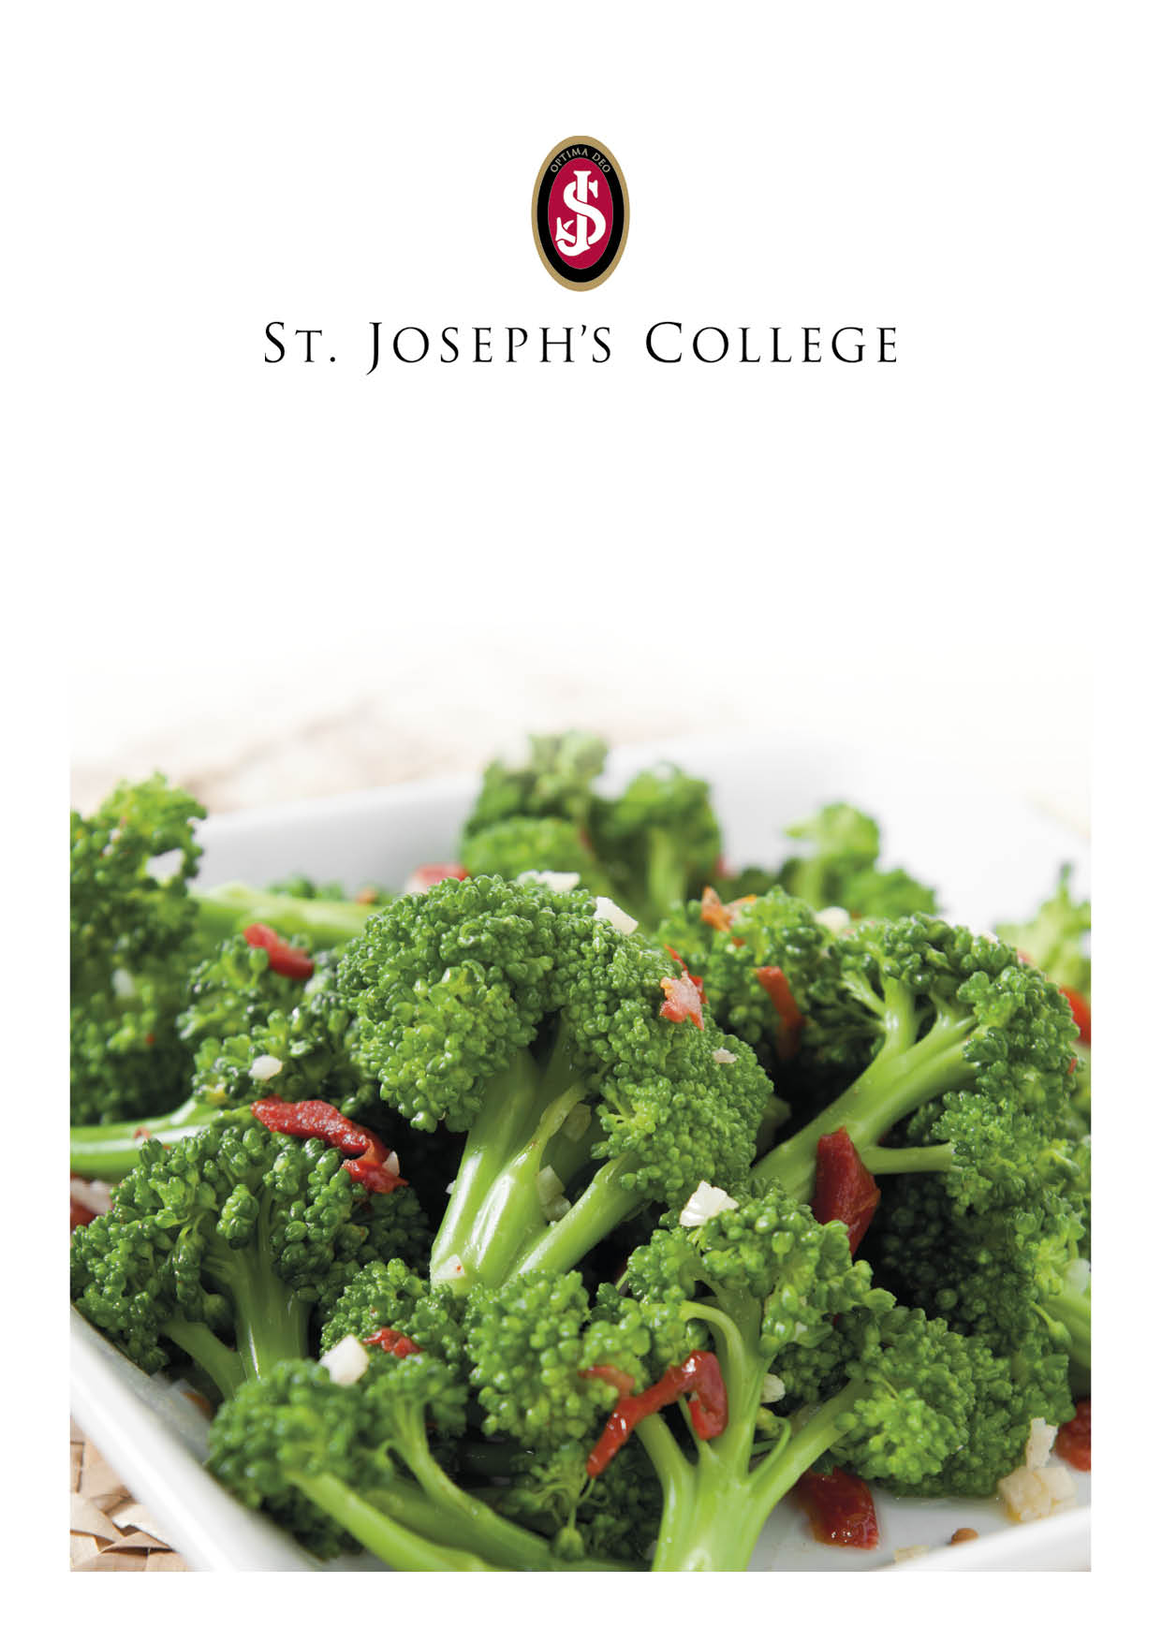
Week Commencing 1 July 2024
Monday | Tuesday | Wednesday | Thursday | Friday
Soup of the Day  Pea and Ham  served with Home Made Bread  Dish of the Day  Thyme and Rosemary Roast Chicken  Vegetarian Option  Spinach and Cheese Flan  Sides  Roast Potatoes  Mixed Root Vegetables  Vegetarian Gravy  Pudding  Blueberry Muffin  Available Daily  Jacket Potatoes  Baked Beans  Pasta  Salad Bar  Fresh Fruit | Soup of the Day  Potato with Sour Cream & Chive  served with Home Made Bread  Dish of the Day  (Pasta Bar)  Beef  Bolognaise  Vegetarian Option  Tomato and Roasted Pepper Penne Pasta  Sides  Garlic Bread  Roasted Ratatouille Vegetables  Pasta in a Herb Dressing  Pudding  Belgian Waffle served with a Chocolate Custard  Available Daily  Jacket Potatoes  Baked Beans  Pasta  Salad Bar  Fresh Fruit | Soup of the Day  Gazpacho  served with Home Made Bread  Dish of the Day  Katsu Chicken Curry  Vegetarian Option  Chunky Roasted Vegetable Korma  Sides  Basmati Rice  Garlic Naan  Roasted Cumin Vegetables topped with Natural Yogurt  Pudding  Raspberry Cheesecake  Available Daily  Jacket Potatoes  Baked Beans  Pasta  Salad Bar  Fresh Fruit

