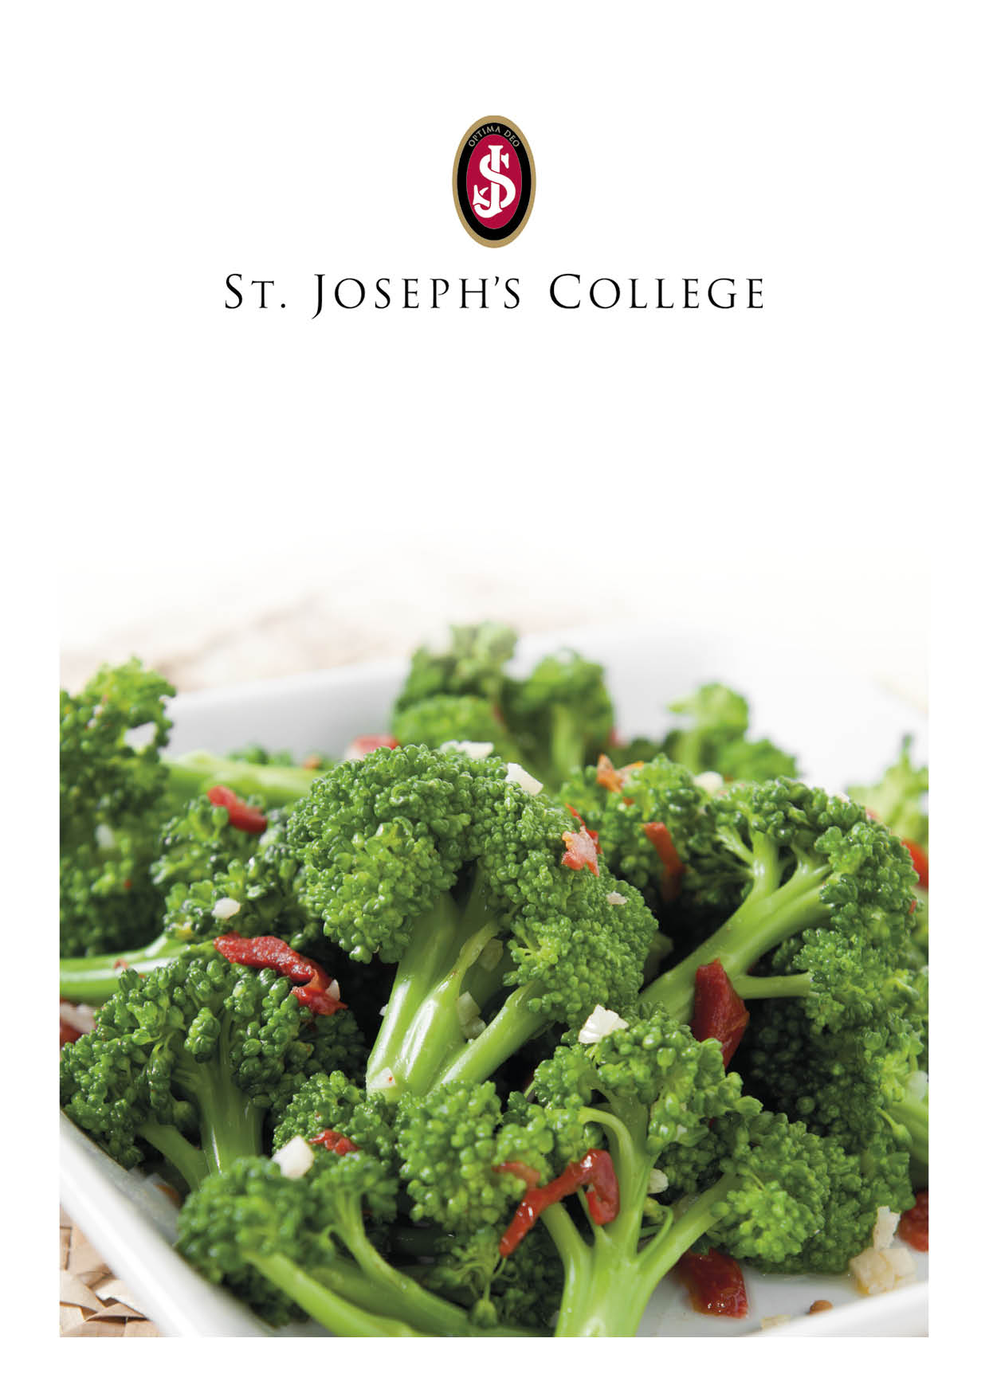
Weekly Break Menu
Monday | Tuesday | Wednesday | Thursday | Friday
Prep. School Morning Break  Pork Sausage Roll  (V) Vegan Sausage Roll  Fresh Fruit  Senior School Morning Break  Pork Sausage Roll  (V) Sausage Roll  Water  Fruit Juice  Fresh Fruit  Afternoon Break  Cheese Panini  Pasta Bake  Fresh Fruit | Prep. School Morning Break  Selection of Yogurts  Fresh Fruit  Senior School Morning Break  Croissant with Jam and Butter  Water  Fruit Juice  Fresh Fruit  Afternoon Break  Fish Finger Baguette  Pasta Bake  Fresh Fruit | Prep. School Morning Break  Vegetable Crudities  Fresh Fruit  Senior School Morning Break  Hot Dog  (V) Vegetarian Hot Dog  Water  Fruit Juice  Fresh Fruit  Afternoon Break  Baked Pretzels  Pasta Bake  Fresh Fruit | Prep. School Morning Break  Spiced and Non-Spiced Chicken Goujons  (V) Cheese Scones  Fresh Fruit  Senior School Morning Break  Breaded Mozzarella Bites  Water  Fruit Juice  Fresh Fruit  Afternoon Break  Baked Potato with Beans and Cheese  Pasta Bake  Fresh Fruit | Prep. School Morning Break  Cheese and Tomato Puff Pastry Wheels  Fresh Fruit  Senior School Morning Break  Pain au Chocolat  Water  Fruit Juice  Fresh Fruit  Afternoon Break  Selection of Sandwiches  Pasta Bake  Fresh Fruit

